**Module 1: Introduction to Transact-SQL > Getting Started with Transact-SQL**

* SQL: Structured Query Language (ANSI standard and later ISO standard)
* Declarative rather than procedural programming language. Is a language specialized with data sets (the set theory branch of mathematics).

**Relational Databases**

Relations (tables/entities) and domains (columns/attributes) and elements (rows or instances).

**Normalized databases**

1. Each table has a unique identifier (primary key

2. Tables are related to each other via foreign keys.

**Schemas**

There are objects in SQL (mostly tables, but they can be sps, views, etc). Those objects are arranged in schemas (namespaces for the objects/tables).

Example of fully qualified name for a table: **[server_name].[db_name].[schema_name].[object_name]** (schema name can be omitted, but beware of possible ambiguity issues)

**SQL Statements types**

**DML (Data Manipulation Language)**

Querying and modifiying data.

SELECT, INSERT, UPDATE, DELETE (they affect rows).

**FOCUS OF THE PRESENT COURSE**

**DDL (Data Definition Language)**

They affect database objects

CREATE, ALTER, DROP

**DCL (DATA CONTROL LANGUAGE)**

Statements for assigning security permissions.

GRANT, REVOKE, DENY

**Module 1: Introduction to Transact-SQL The SELECT Statement**

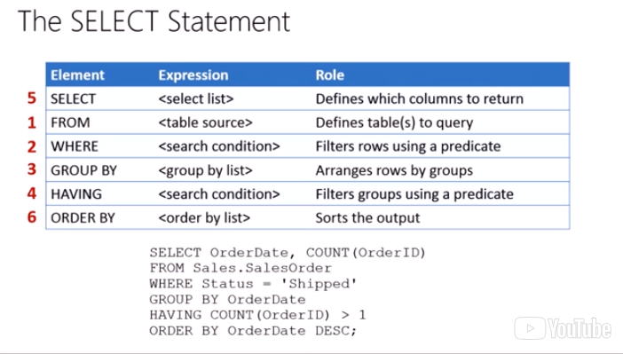

**IN THE IMAGE ABOVE, IN RED, THERE IS A SPECIFICATION OF THE ORDER IN WHICH COMMANDS ARE EXECUTED**

**PERHAPS IS IMPORTANT TO BEAR THAT IN MIND**

Having is a filter over the groups defined in the group by clause. That’s why the having clause goes after the group by.